ITIS 5250

Ruchira Pokhriyal

Lab 3

10/16/2018

**Overview**

In this lab, I am introduced to FTK (Version 6.3.0.186) using which, I will be performing data carving operations, recover jpeg pictures, examin **EXIF** information of the given forensic image and based on the EXIF information, I will be locating GPS coordinates of the found pictures of the image.

**Forensic Acquisition & Exam Preparation**

I am provided with a forensic image which was made by Officer Jimmy Johns, using the subject’s thumb drive. I loaded the image using **FTK Imager** to perform hash verification and also verified whether any bad sectors are present in the device. I also used **FTK** for evidence processing.

**Description of the image:**

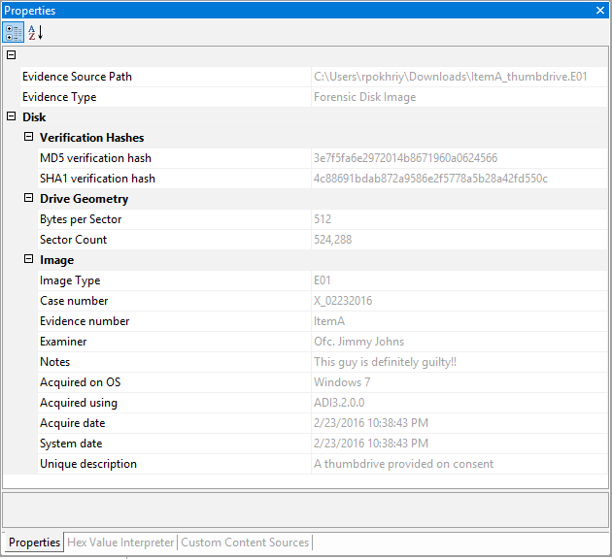

Both, the stored and computed hash values match:

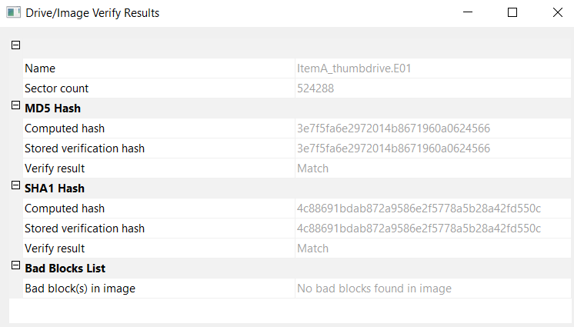

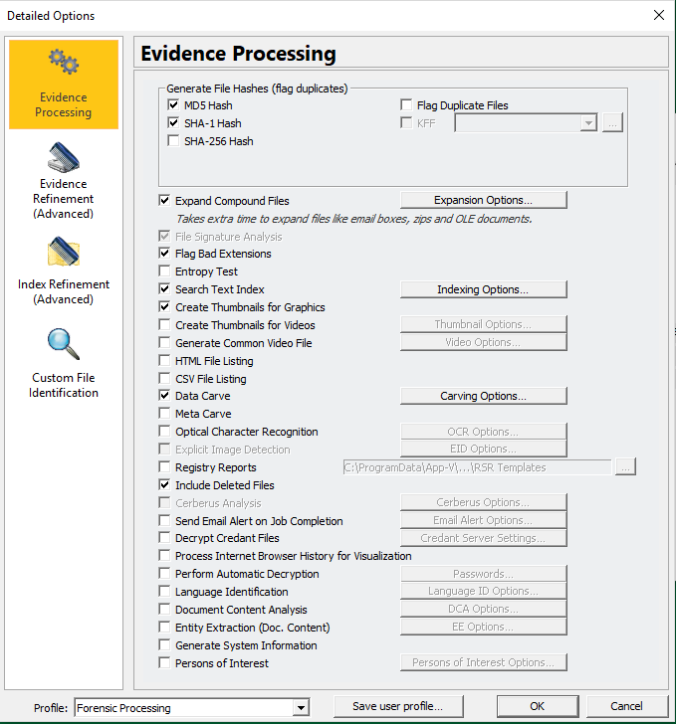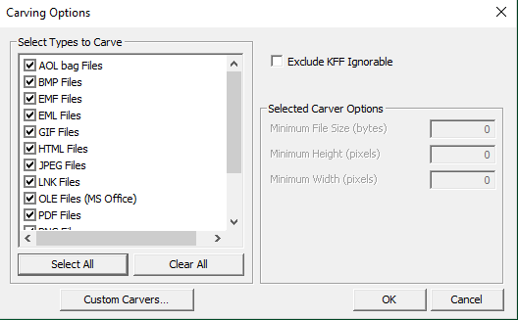**Evidence Processing using FTK: Carving Options:**

**Adding Thumb Drive Image:**

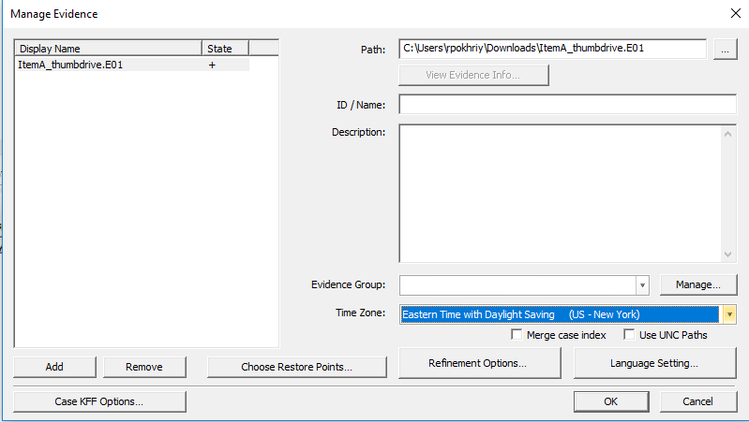

**Findings and Report (Forensic Analysis)**

**I followed the following steps to load the image to FTK:**

Open FTK-> Case->New->Add case name and location of your folder->Customize->Select “Data Carve” in Evidence Processing->Go to “Carving Options”-> Select all the file types to be carved->Click OK.

Next, to add thumb drive through “Manage Evidence” pane->Add-> Add the downloaded thumb drive image->Select the appropriate time zone (Eastern time zone with daylight saving (US- New York) in this case)-> OK.

After loading the image into FTK, I performed **carving** **operation**, to recover deleted pictures from the provided image.

The first image I verified is the **image ‘1343488.jpeg’** as shown below. The image appears to be of a **Mac Mini.**

(Location: Under Evidence Items, go to Evidence\ItemA_thumbdrive.E01\Partition 1\JUMPDRIVE [FAT32]\ [unallocated space]\007906\ Carved [1343488].jpeg )

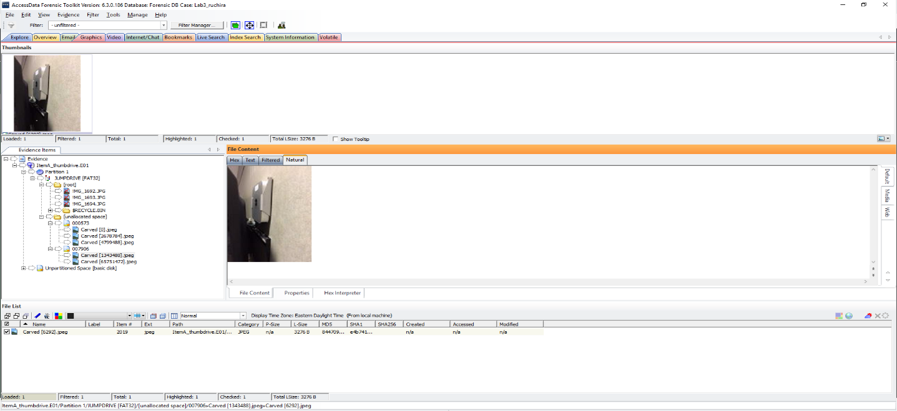

Under the properties tab, I examined the **EXIF** information, and the details in the below screenshot show that that the image was taken from the camera of an iPhone 6s:

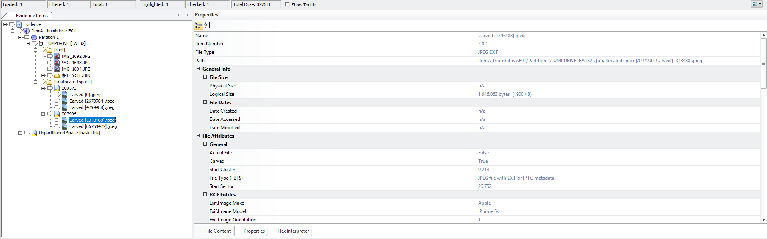

The below screen shot outlines the EXIF details of the picture which contains the GPS location where the image was taken:

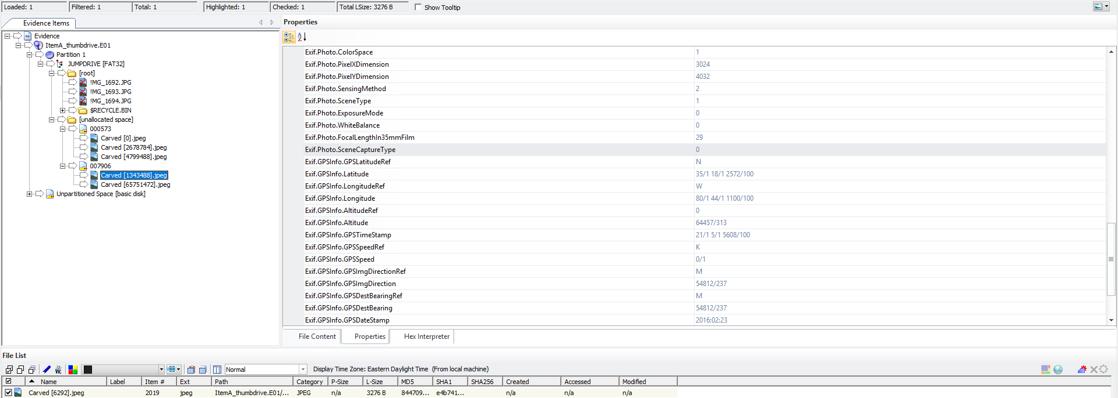

Similarly, **I verified the image ‘65751472.jpeg’**. The image appears to be of a **Mac Mini**.

(Location: Under Evidence Items, go to Evidence\ItemA_thumbdrive.E01\Partition 1\JUMPDRIVE [FAT32]\ [unallocated space]\007906\ Carved [65751472].jpeg )

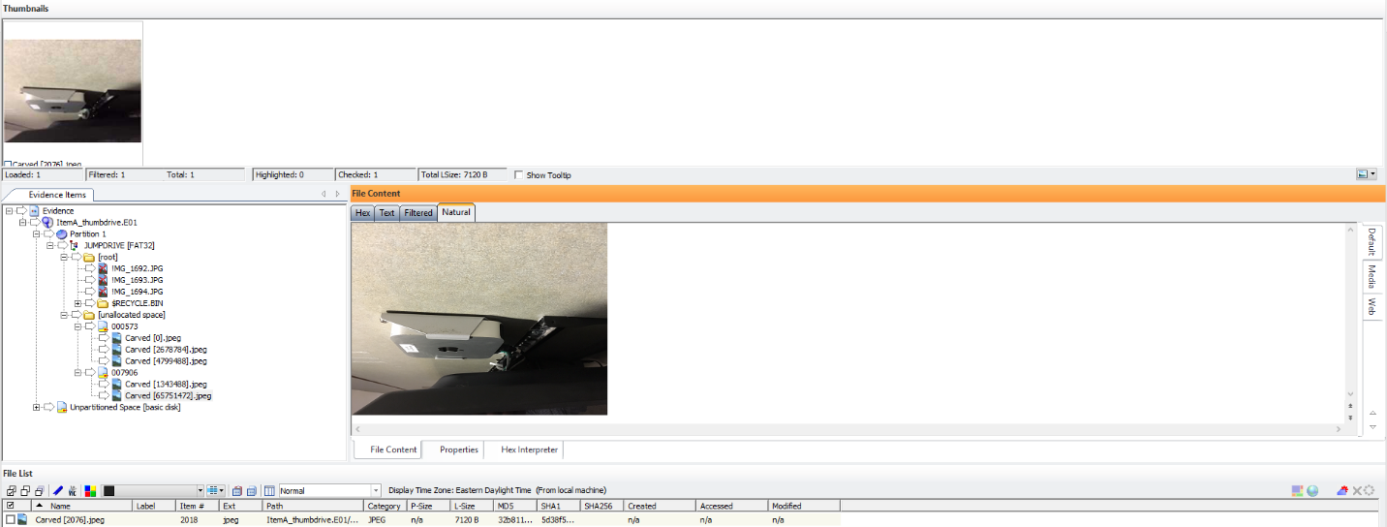

Properties:

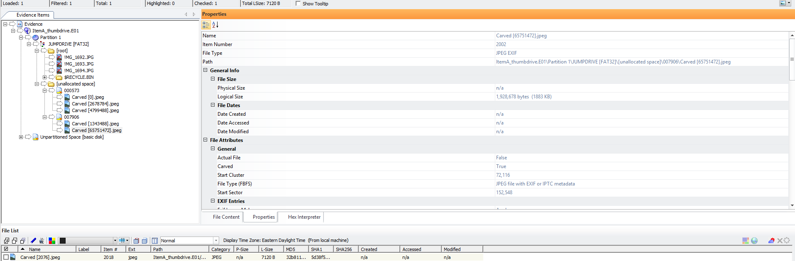

I examined the **EXIF** information, and the details in the below screenshot show that that the image was taken from the camera of an iPhone 6s:

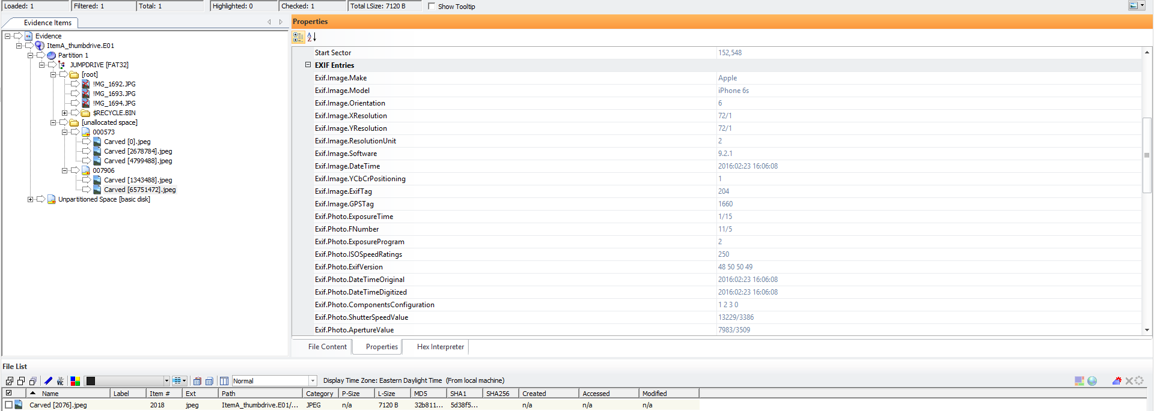

GPS location where the image was taken:

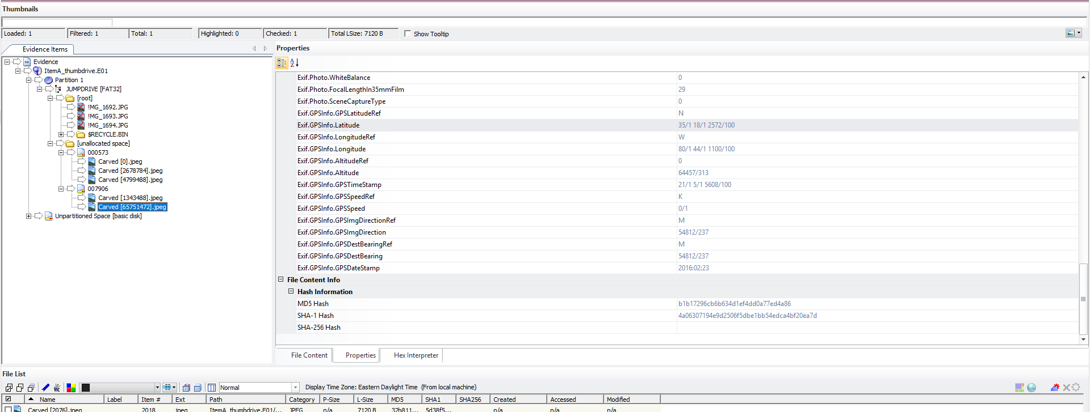

The **EXIF information** shown above, provides details regarding **device make, model, date, time and GPS coordinates** of these two jpeg pictures (Carved [1343488].jpeg and Carved [65751472].jpeg).

I then fed the GPS coordinates into **Google Maps**, and as shown below and found that these jpeg pictures were captured at the **Woodward Hall at** University of North Carolina at Charlotte.

**GPS coordinates of Carved [1343488].jpeg and Carved [65751472].jpeg:**

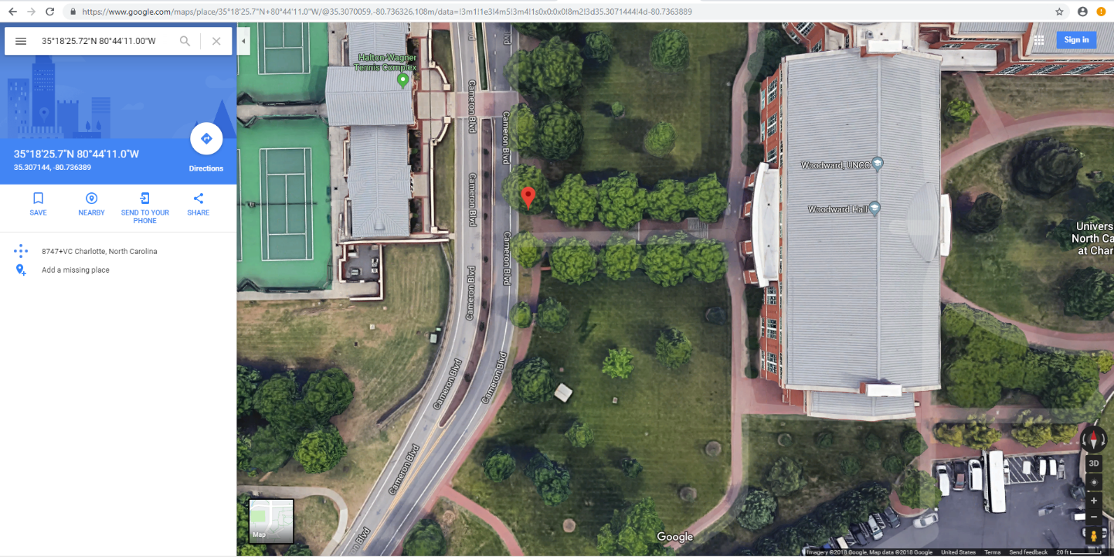

In FTK, I found **three** jpeg pictures in the recycle bin:

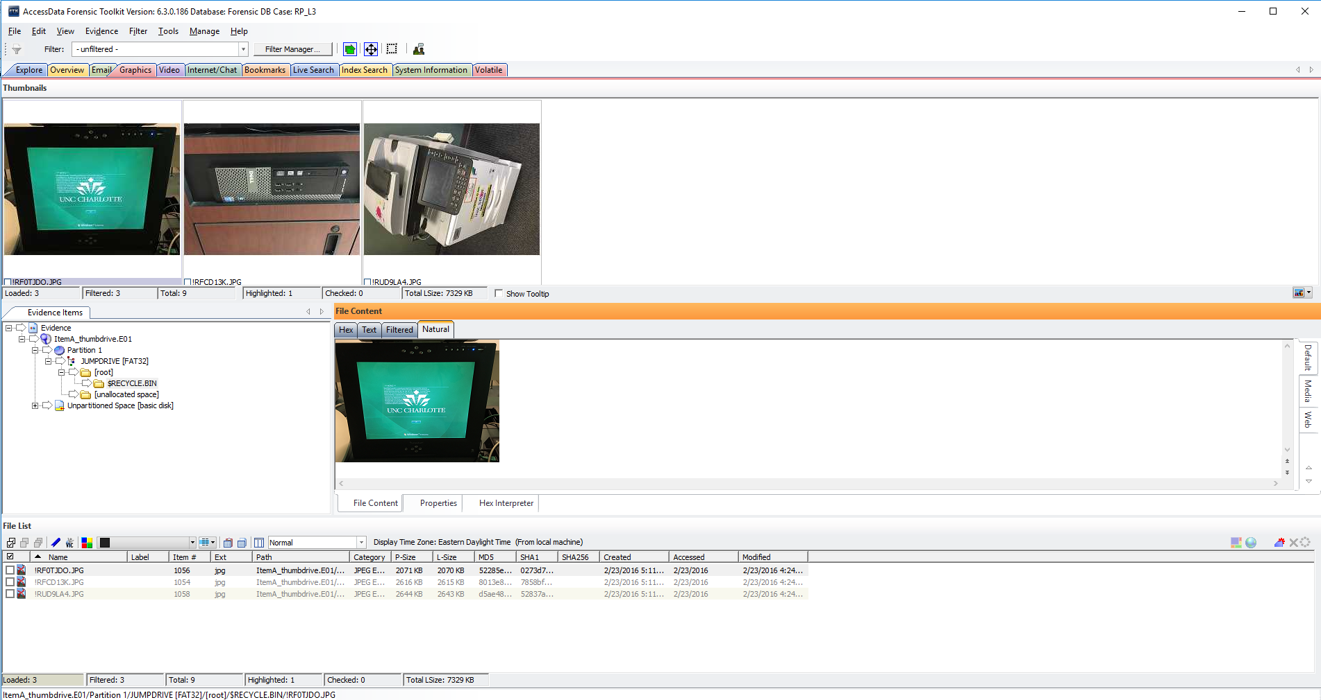

I found out the device model, date, time and GPS coordinates of these three pictures by looking at their respective **EXIF** information under the property tab and found out the specific locations where these pictures were taken by loading the GPS coordinates of all these pictures into Google Maps. **Below are the results:**

**!RF0TJDO.jpg- A monitor screen:**

(Location: Evidence\ItemA_thumbdrive.E01\Partition\JUMPDRIVE [FAT32]\ [root]\ $RECYCLEBIN\!RF0TJDO.JPG)

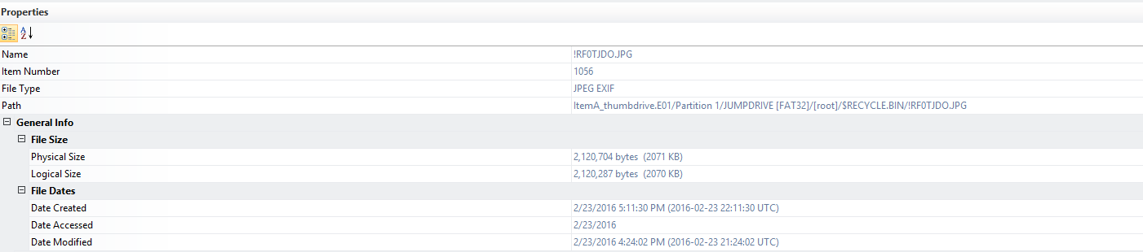

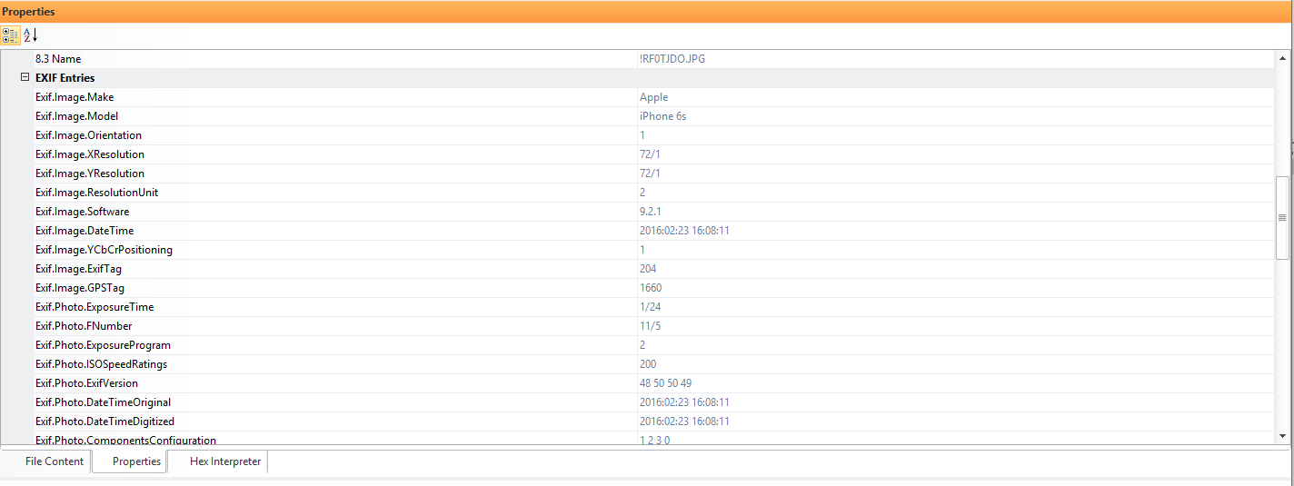

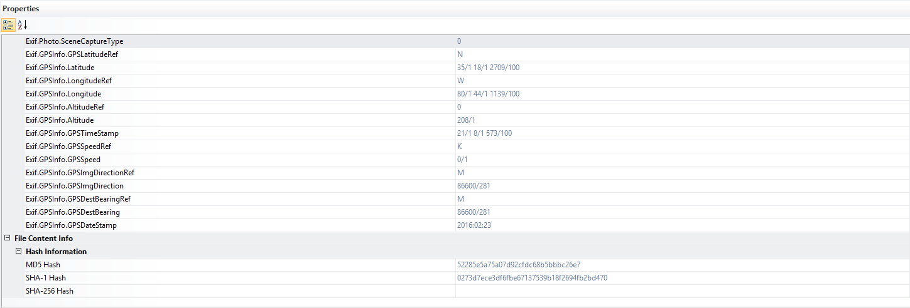

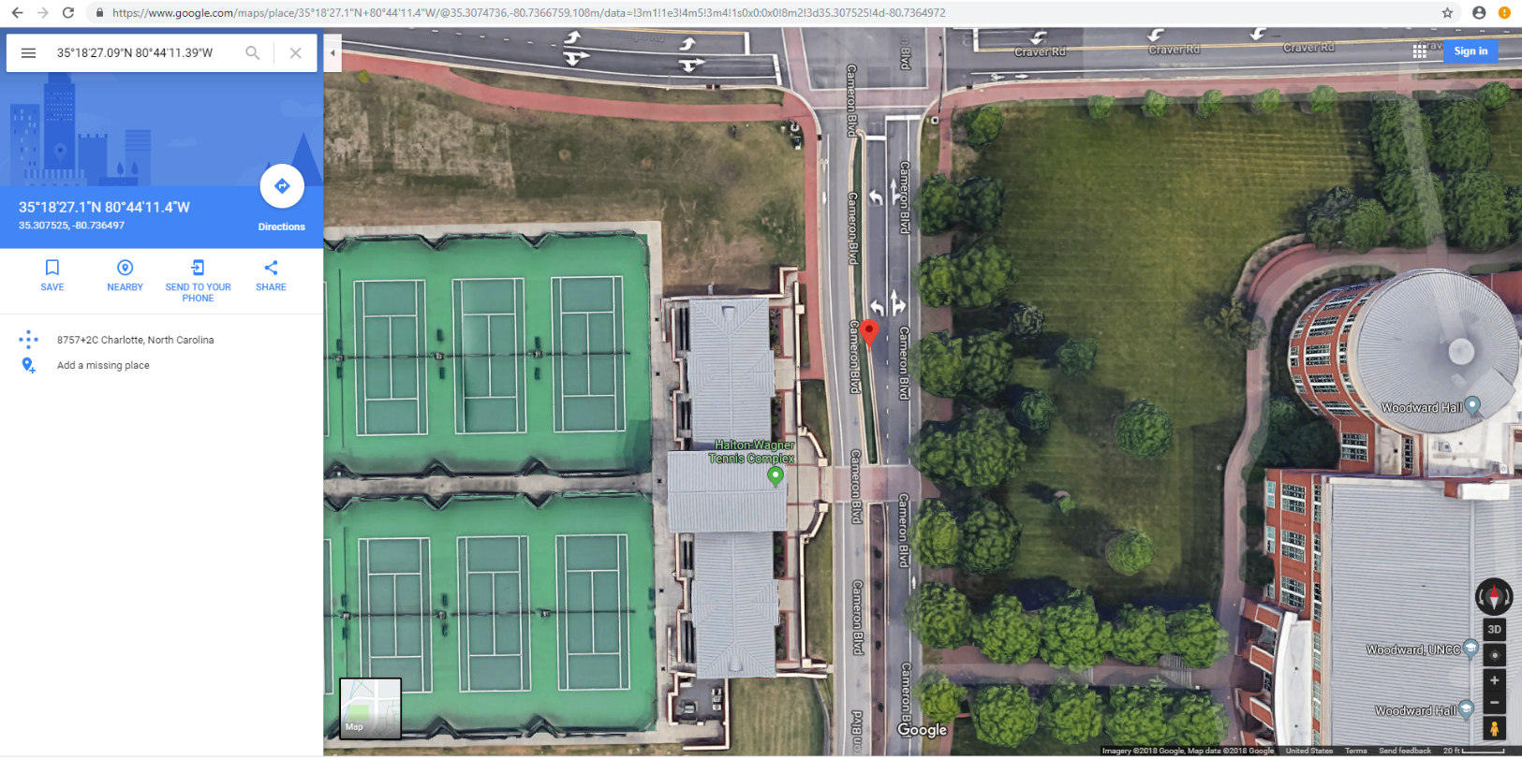

**!RFCD13K.jpg- A CPU:**

(Location: Evidence\ItemA_thumbdrive.E01\Partition\JUMPDRIVE [FAT32]\ [root]\ $RECYCLEBIN\!RFCD13K.JPG)

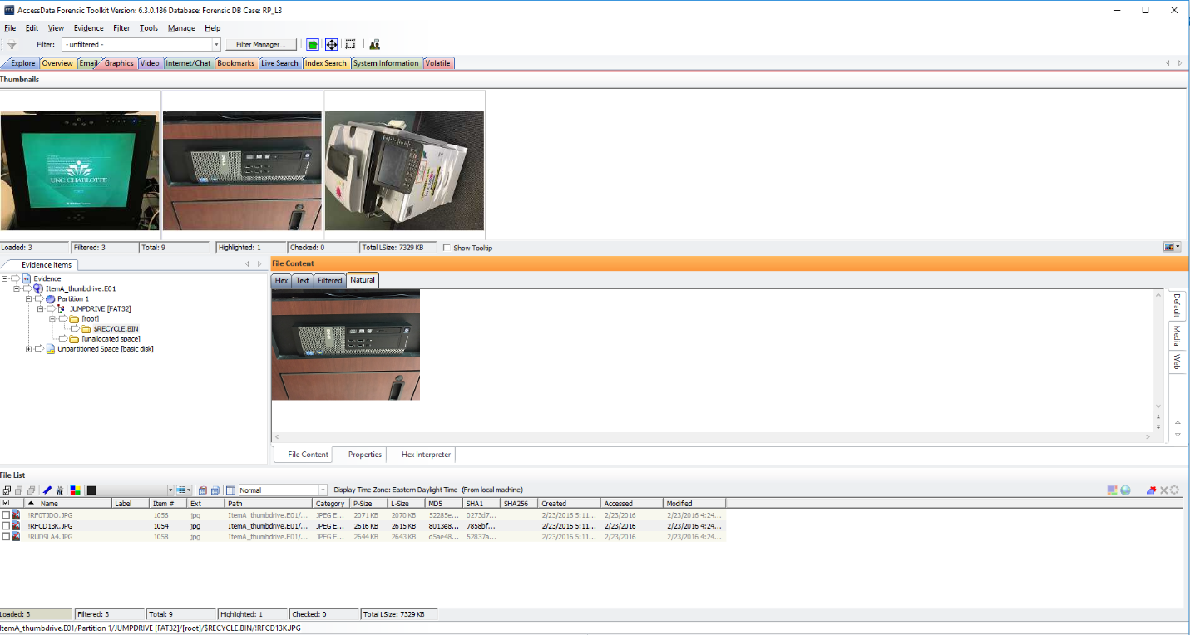

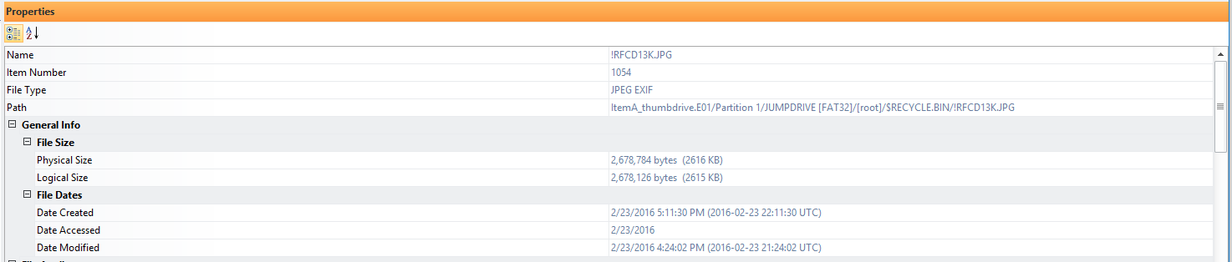

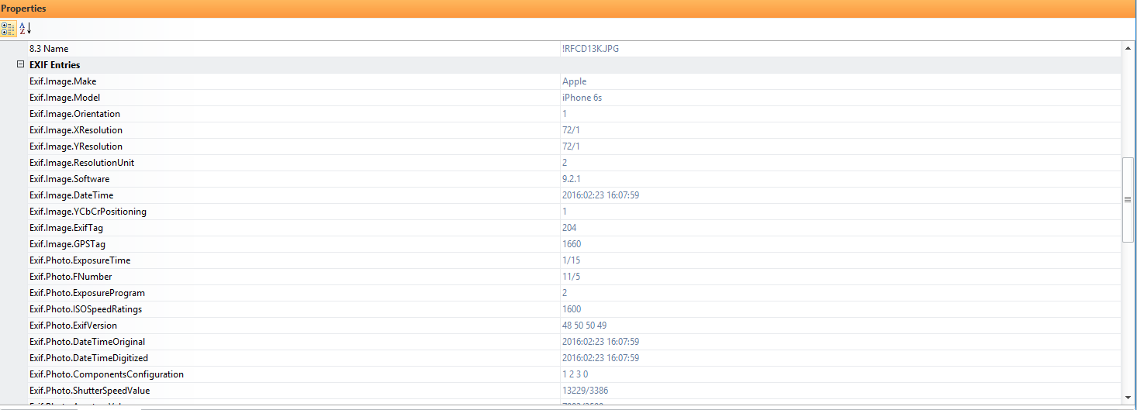

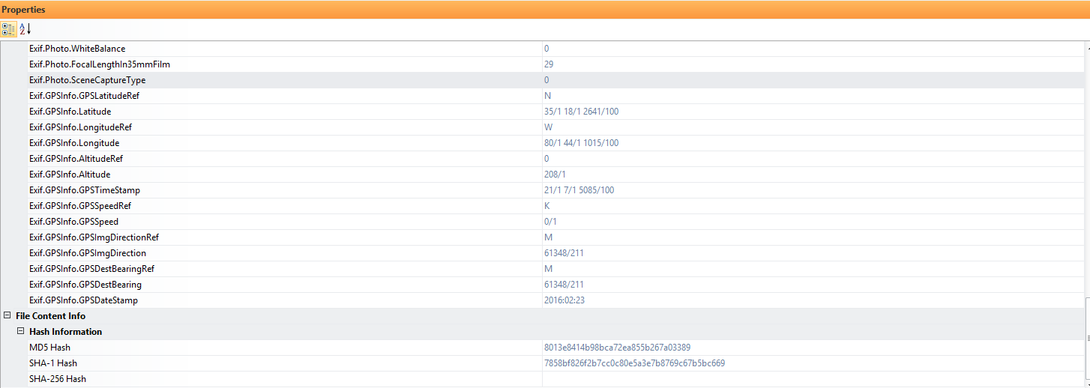

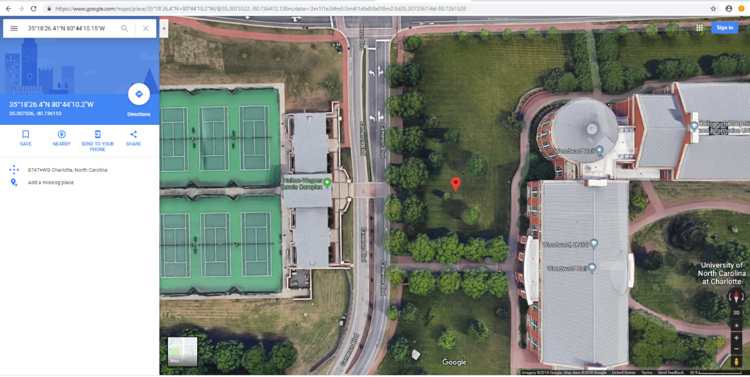

**!RUDLA4.jpg- A printer:**

(Location: Evidence\ItemA_thumbdrive.E01\Partition\JUMPDRIVE [FAT32]\ [root]\ $RECYCLEBIN\!RUDLA4.JPG)

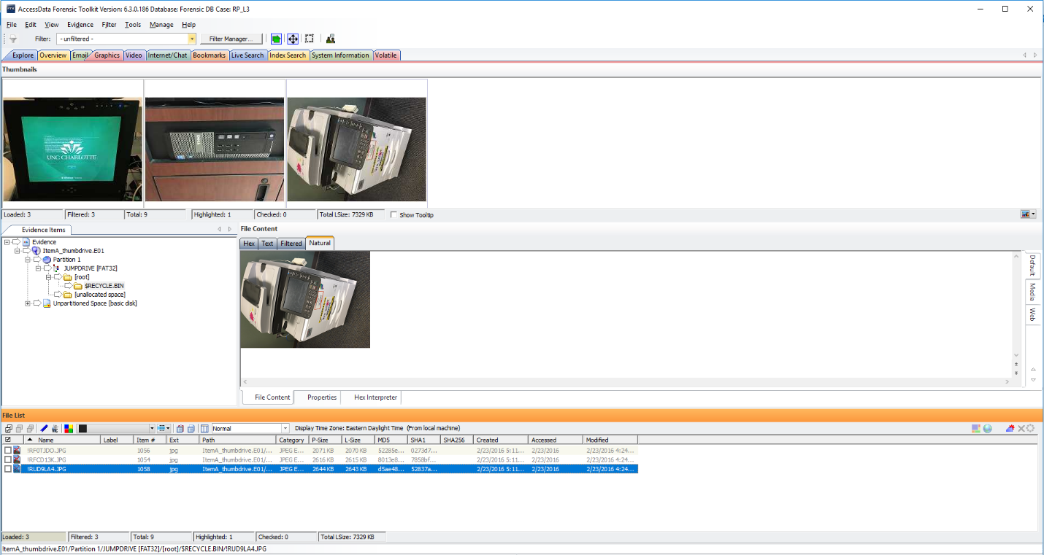

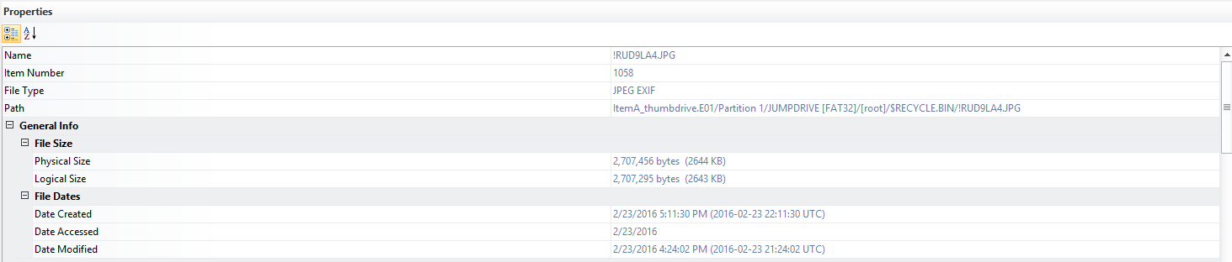

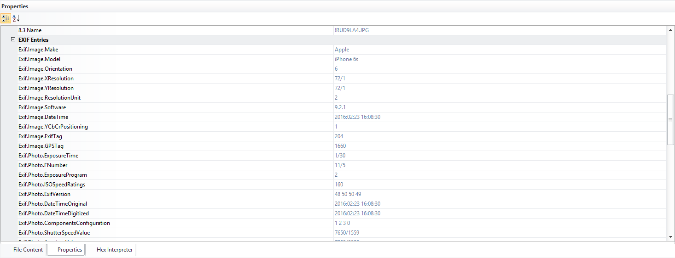

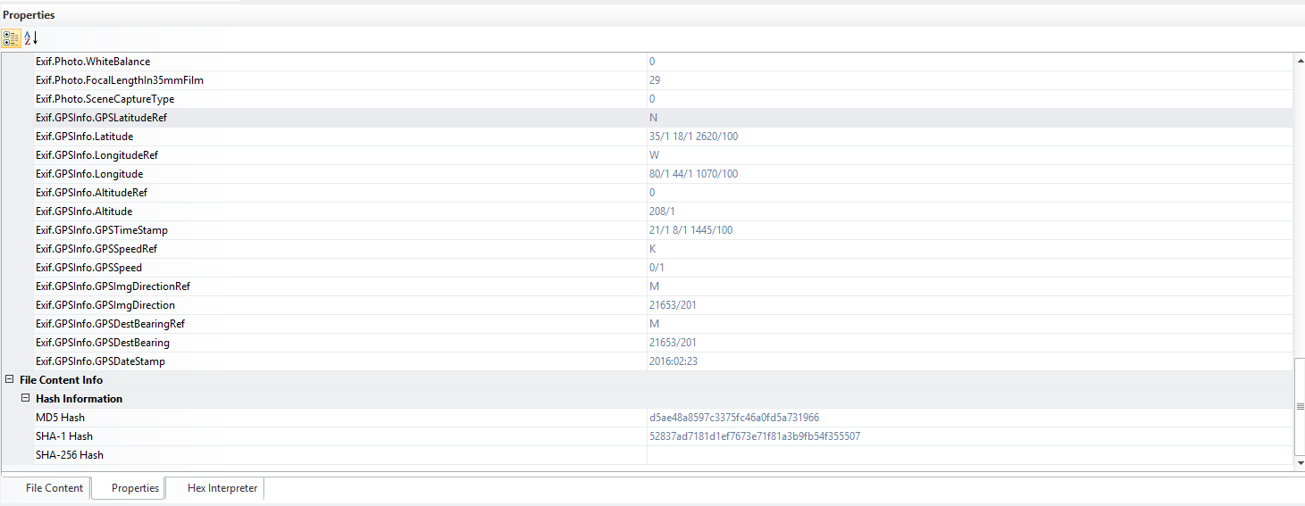

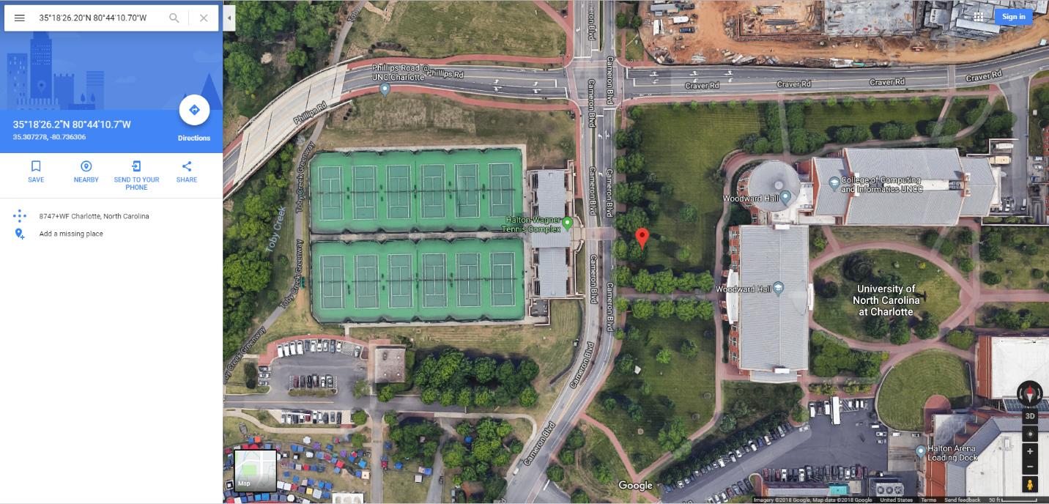

**Conclusion**

I examined the image provided by Officer Jimmy Johns, performed **data carving** operation, examined the recycle bin of the given image and recovered .jpeg pictures. Additionally, I located the specific GPS coordinates found in the **EXIF** information of the pictures using Google Maps, and the location was found to be the Woodward Hall at University of North Carolina at Charlotte.